Sponsored research project (No: 2019-SESM-07)
Cemetery-based notification and cause-of-death in resource-limited settings in Bangladesh: A pilot study
Mohammad Sorowar Hossain^{1.2}, Abdullah Al Mamun², Mohammad Tariqul Islam³ and Enayetur Raheem²
- Department of Environmental Science and Management, School of Environment and Life Sciences, Independent University, Bangladesh
- Department of Emerging and Neglected Diseases, Biomedical Research Foundation, Bangladesh
- Jamalpur General Hospital, Jamalpur Sadar, Bangladesh

Abstract
Background: Reliable cause-specific mortality information is vital to identify the health needs of a community, monitor the progress of preventive intervention programs, and track the changes over time. In Bangladesh, only one out of ten deaths is recorded at the national level. A significant proportion of deaths that occur at home and in private healthcare settings are largely unreported. The surveillance of all households and hospitals (public and private) in a community for death notification and registration requires huge investment and resources. In this context, monitoring cemeteries as a catchment point for death notification and cause of death (CoD) registration could be cost-effective. Thus, a cemetery-based approach could cover nearly one-third of the country’s population (nearly 50 million in 328 municipalities) for CoD registration at the municipality level. This pilot study aimed to: (i) determine the prevalence of causes of death among the adult population in a community setting and (ii) examine the feasibility of the cemetery-based death notification and cause of death registration.
Methods: This study was conducted at Jamalpur municipality in collaboration with Biomedical Research Foundation (BRF) and Civil Surgeon, Jamalpur District. A validated WHO verbal autopsy (VA) instrument was used to determine the CoD after receiving the notification from the cemeteries.
Result: Among 117 adult death cases analyzed, 60.7% were male. The mean age of death cases was 66.2 (SD 18.2) years. More than two-thirds (~68%) of cases had no medical records and a death certificate was issued for only one-third of cases. Most death cases (over 90%) were attributed to non-communicable diseases. Stroke was the most prevalent cause of death (35.5%) followed by cancers (9.4%), acute myocardial infarction (7.7%), chronic respiratory diseases (~6.5%), diabetes (~6%), and kidney diseases (4.2%).
Conclusion: To the best of our knowledge, we, for the first time, propose an innovative cemetery-based approach for profiling disease-specific mortality in a community setting. Stroke was the most prevalent cause of death followed by cancer in a community setting. This pilot study has paved the way to conduct a large-scale study.
Preliminary analysis

Measure | Item | Count | Percentage
Gender | Male | 69 | 61.1%
 | Female | 44 | 38.9%
Age (Years Old) | 18 or below | 3 | 2.7%
 | >18≤35 | 5 | 4.4%
 | >35≤45 | 15 | 13.3%
 | Above 45 | 90 | 79.6%
Occupation | Farmer | 13 | 11.5%
 | Day Labourer | 13 | 11.5%
 | Housewife | 38 | 33.6%
 | Businessman | 21 | 18.6%
 | Others | 28 | 24.8%
Educational Qualifications | Illiterate | 51 | 45.1%
 | Primary | 30 | 26.5%
 | Secondary | 24 | 21.2%
 | Higher Secondary | 2 | 1.8%
 | Graduate | 6 | 5.4%

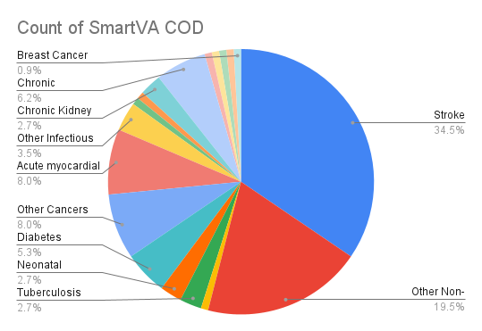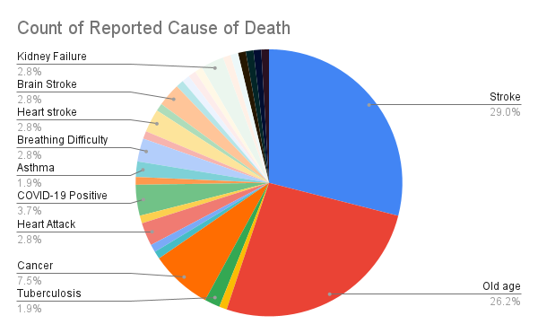

- Significance of the Project:
Explain if your Research Project is aligned with the IUB Research Priorities and Education and/or Service Mission of your respective School. Describe the scholarly impact of your Research Project and significance in terms of innovate idea. (Approximately 300 words)
Healthy population is the key for sustainable growth of a country. Reducing disease burden, therefore, lies at the heart of Sustainable Development Goals. Bangladesh has made remarkable progress in the health sector by reducing communicable diseases; however, the issue of non-communicable diseases (NCDs) is less prioritized. Currently, NCDs are the most common cause of mortality and morbidity worldwide, and the numbers are on the rise. According to WHO, nearly 63% of NCDs related deaths are attributed to heart diseases, diabetes, cancers and chronic respiratory diseases. The socioeconomic impacts and health costs of NCDs are enormous. Thus, control of NCDs bears great significance in alleviating poverty. Moreover, NCDs have strong association with environmental factors like pollution, diets, lifestyle, work environment etc. Our project is expected to find out the spectrum of NCDs and associated factors at community level, which in turn, will serve as a crucial resource for health monitoring and service planning. This is in line with the IUB’s research and education priorities as well as the mission of Environmental Management Department which promotes human well-being and sustainable economic growth.

In Bangladesh, cause-specific mortality data is scarce. We, for the first time, are proposing a cost-effective and innovative cemetery based approach for profiling disease specific mortality at a community setting. Generated data on preventable and modifiable causes of death will help to identify new health priorities. In addition, the scope for studying environmental risk factors will also be increased at population level. In short followings are expected:

- Data from this pilot study would attract national and international research grants/collaborations to scale up this project.
- This cemetery-based innovative could be cost-effective and less resource oriented, which could be replicated in 328 municipalities in the country.

- Theoretical background:
Details of the proposed research with objective and theoretical background. (Approximately 300 words)
Simply counting the number of deaths is not enough to develop an understanding of population-level disease profiles. Reliable cause-specific mortality data are required to identify the health needs of a community, monitor progress of preventive intervention programmes and track the changes over time. Research has shown that disease profiles appear to be heterogeneous within a country depending on exposure to various environmental risk factors.

In Bangladesh, there is little empirical data on patterns and trends of cause of death (CoD) among adults at national level. Furthermore, Deaths in the homes and private health facilities remain largely unreported. According to Directorate General of Health Services of Bangladesh (DGHS); only one out of ten deaths are recorded at national level. However, those records are based on data from public hospitals where the cause of deaths is reported based on morbidity coding, not mortality coding.
In settings such as Bangladesh, civil registration of deaths is incomplete and medical certification of death is not common practice, verbal autopsy (VA) is a scientific, practical, and low-cost approach to generate population-based information on CoD for health sector planning, implementation, and monitoring. Systematic death notification is also nonexistence in Bangladesh.
In a resource-limited country like Bangladesh, the surveillance of all households and hospitals (public and private) in a community for death notification and registration requires huge investment and resources. In this context, monitoring of cemeteries of a community, particularly in municipalities, as a catchment point for death notification and registration would be cost-effective, and require less manpower/resources. Because of space constraints and high prices of land in towns/municipalities, most people prefer public cemetery to bury their loved ones. There are 328 municipalities throughout the country where over 50 million people are currently living. Thus, cemetery-based approach could cover about one third of country’s population for CoD registration with minimum resources.
Specific objectives:
- To establish cemetery based death notification in a community setting, particularly in municipalities.
- To assess cause-specific disease profile at a community setting using cemetery based approach.
- To determine the association between cause-specific diseases and socio-economic factors at community level.

- Methodology:
Please provide the methodology of the Research Project with data collection, data analysis and processes in details. (Approximately 300 words)
This study will be conducted at Jamalpur Pauroshova/municipality where Biomedical Research Foundation (BRF), a partner of this project, has already established a community-based research platform and networks. This study will capitalize on these resources and experiences obtained from that community.
Study setting: Jamalpur Pauroshova, is comprised of around 35,000 households with a population size of approximately 150,000 (BBS, 2011). This is a Muslim dominated (approximately 90%) community where almost all deceased are buried in the public cemeteries. All cemeteries (three muslim and one Christian) and cremation centre (Hindu) of Jamalpur Pauroshova will be under surveillance for capturing death cases for VA interview.
Instrument: This study will use a standardized and validated verbal autopsy (VA) tool to determine CoD. The VA tool gathers information from a close caregiver about the signs and symptoms of the deceased's terminal illness, existing medical records as well as lifestyle behaviours and other characteristics.
Data collection analysis: For cemetery-based death notification, a specific form will be developed which will be filled up by the attendants of the cemeteries. One field worker will be recruited locally to ensure a common cultural background with the local community for collection data after proper training by a team of medical doctors. Collected information will be used to derive probable causes of death, most commonly through independent review of the data by a team of physicians who try to reach consensus on a single cause. SmartVA-Analyze software will be used to collect and analyse VA data.

BRF Project title: Estimation of community-based death-specific noncommunicable disease burden using verbal autopsy in Bangladesh

Background/Rationale
Noncommunicable diseases (NCDs) are currently leading causes of death and disability worldwide. These are rising rapidly as the population is ageing and developing countries undergoing demographic transition. According to WHO estimates, nearly 80% of NCD deaths occur in developing countries. In 2008, nearly 63% of NCDs related deaths are mainly due to cardiovascular diseases, diabetes, cancers and chronic respiratory diseases [1].
Due to better control of infectious disease, increasing life expectancy and slowing population growth, Bangladesh is now experiencing the double burden of communicable and noncommunicable diseases (NCDs) [2]. At present, NCDs account for 59% of total deaths (WHO) in our country (World Bank). This scenario has created a strain on the existing healthcare system which is inadequately designed and resourced to care for people with chronic noncommunicable diseases and injury related conditions.
The civil death registration system is nonexistence in Bangladesh. Many developing countries including Bangladesh lack routine, representative and high quality information on the levels and causes of death [3]. This is crucial for health programs, health and development policies; program monitoring and evaluation purposes [4]. Verbal autopsy is the most commonly used method to determine cause of death in places lacking adequate civil registration, where the majority of deaths occur outside of medical care [5,6]. In verbal autopsies, the cause of death is determined by trained physicians based on the description of symptoms and circumstances leading to death.

Objectives
- Profiling of chronic diseases based on cause-specific mortality.
- Investigation of sex- and age-specific death prevalence in the community.
- Monitoring of epidemiological transition of double burden in mortality from communicable and noncommunicable diseases.

Overall study plan and methodology
WHO-Standardized verbal autopsy (VA) tool will be used to conduct this study. The verbal autopsy is interviewing relatives or caregivers about the signs, symptoms, lifestyle behaviors and other characteristics experienced by the deceased before their death and the circumstances surrounding their death.
Study area: We will conduct this study at Jamalpur Pauroshova, which comprises of around 35,000 households with a population size of approximately 150,000 (BBS, 2011). This is a Muslim dominated (approximately 90%) semi-urban area where almost all deceased are buried in the public cemeteries. All cemeteries and cremation (in case of Hindu) centre of Jamalpur Pauroshova will be under surveillance for capturing death cases for VA interview.

Data collection for verbal autopsy: Field workers will be recruited locally to ensure a common cultural background with the local community. The verbal autopsy questionnaire adapted from a standardized WHO will be translated into Bengali. The physician review method will be used to determine causes of death.

Outcomes
- Our study would provide baseline data to assess the prevalence of death caused by chronic diseases.

- Data on preventable and modifiable causes of death will help to identify new health priorities which would lead to more appropriate allocation of resources and assist in the evaluation of health programs.

- Our data would provide valuable information for clinicians and policy makers. Modules added to the verbal autopsy can determine the prevalence of important risk factors and health-related behaviors in the deceased persons.
References
- World Health Organization (2011). Global status report on noncommunicable diseases 2010. Description of the global burden of NCDs, their risk factors and determinants.

- Mahmood SAI, Ali S. & Islam R. (2013). Shifting from infectious diseases to non-communicable diseases: A double burden of diseases in Bangladesh. Journal of Public Health and Epidemiology, 5(11), 424-434.

- Mathers C, Ma Fat D, Inoue M, Rao C, Lopez AD (2005). Counting the dead and what they died of: an assessment of the global status of cause of death data. Bull World Health Organ. 83: 171-177.
- Byass P (2007) Who needs cause-of-death data? PLOS Med 4(11): 333.

- Fottrell E (2009) Dying to count: mortality surveillance in resource-poor settings. Glob Health Action 2: 10.

- Kahn K, Tollman SM, Garenne M, Gear JS (2005) Validation and application of verbal autopsies in a rural area of South Africa. Trop Med Int Health 5(11): 824–831

Well-functioning vital registration (VR) systems are essential to monitor health progress and inform health policy. They are a critical input for public health analyses, understanding epidemiological patterns, and allocating scarce resources for public health and medical care. Most developed countries have complete or near complete VR systems, with reasonably accurate cause of death data. However, VR systems in low- and middle-income countries (LMICs) are generally incomplete in reporting causes of death, and the need for representative, quality data on leading causes of death is even greater [1].
Reports of hospital deaths are available from nearly all LMICs. In the absence of a comprehensive VR system, many countries use hospital deaths as the basis for their cause of death (COD) reporting and the identification of health priorities [2]. The advantage of hospital-based reporting of deaths is that hospital practitioners have the investigative capacity to discriminate between conditions with common sets of symptoms, although this does not necessarily mean that causes of hospital deaths are being accurately diagnosed [3, 4]. The disadvantage of using hospital data to extrapolate cause-specific mortality fractions (CSMFs) to whole populations is that hospital deaths are a biased sample of all deaths and thus are unlikely to accurately represent the distribution of deaths by cause in the population.

